

Credit Card Fraud Modeling and Deployment

**Interim Report**

Higher Diploma in Science in Data Analytics

Word Count: 1500

Author: Ciaran Finnegan / 10524150

E-mail: [10524150@mydbs.ie](mailto:10524150@mydbs.ie) / [ciaran@feefinnegan.com](mailto:ciaran@feefinnegan.com)

Supervisor: Dr Shahram Azizi Sazi

Report Submission Date: 14th August 2020

**Acknowledgments**

A brief paragraph or two acknowledging professional advice and help in submitting the report.

# Contents

Contents 2

1. Introduction 3

2. Background 4

3. Requirements: Specification and Design 5

3.1. Project Mission Statement 6

3.2. Project Requirements 7

3.3. Project Design 8

3.3.1. User Story Structure 9

3.3.2. User Story 4 – Initial Data Modelling and User Interface ‘Shell’. 10

3.3.3. User Story 5 – Shiny App Prototype 11

3.3.4. User Story 6 – Integrated Prototype 12

3.3.5. User Story 7 – Feature Enhancements 1 13

3.3.6. User Story 8 – Feature Enhancements 2 14

3.3.7. User Story 9 – Final Project Refinements 15

4. Project Testing an Evaluation 16

5. Demonstration of Progress 17

6. Future Work 0

7. Appendices 1

8. References / Bibliography 2

# Introduction

The introduction provides the reader with an overview of the project.

A good introduction will inform the reader what the project is about without assuming any specialist knowledge and without detail that may obscure the overview. The reader is assumed to be knowledgeable but not necessarily an expert in the field of the project.

The introduction should anticipate and combine main points described in more detail in the rest of the report.

The Introduction contains:

• the aims of the project;

• the scope of the project;

• the approach used in carrying out the project;

• assumptions, if any, on which the work is based.

Strengthen the aim/objective -

# Background

The purpose of the background is to provide the reader with the information that they may not know but which they will need in order to fully understand and appreciate the rest of the report.

The following is an indicative list of items that should be included in the background section:

* + the context of the project;
  + the anticipated benefits of the system; typical users of the project product;
  + any theory associated with the project;
  + the analytics methods/theories/algorithms used; any relevant/similar existing software/hardware

# Requirements: Specification and Design

The requirements specification must include the following:

Project/Business requirements

* What is the business/project need or problem? What business questions do we need to answer?
* Information requirements
* What data is necessary to answer those questions? Functional requirements
* How do we need to use the resulting information to answer those questions? Detailed report / usage req.
* Detailed layout etc. Other requirements
* All other non-functional requirements, etc.

The Design should include the high level design to meet the requirements.

In brief:

* Requirements Specification
* Design: The top-level details to meet the specification.
* Tools and Techniques: Evaluation and research to apply theories, models, methodologies and tools for the data analytics project.
* Use of diagrams, such as entity-relationship and UML diagrams

Strengthen – project objective Machine learning application…

Review ML papers for research… and related works…Chapter 2…

Refer to the paper and which model is best for CC classification…

Chapter 3…methodology on ML approach – which algorithm…and why picked them…

Add..Data understanding…CRISP-DM..framework and decision making process..

Read up on Fraud classification – find papers…

Look at Boosting methods…to select the most accurate model…

## Project Mission Statement

What is the goal of this project? What business objective does it attempt to achieve?

This project intends to deliver a working system to allow a user assess a given single credit card transaction, and obtain a prediction as to whether the transaction is likely to be fraudulent.

<image?>

## Project Requirements

In order to achieve the objectives of the project mission statement, the following requirements must be met;

* A predictive model for Credit Card fraud detection must be built using an effective Machine Learning workflow process, which produces results that are as accurate as reasonably possible.
* A dataset is provided with sufficient volume and richness of attributes to allow for appropriate data preparation and modelling to be executed.
* All development and system execution is conducted on cloud based platforms. There is no dependency on local PC libraries or IDEs, and so on;
* All model development and deployment is conducted through the cloud based Azure Machine Learning Studio platform.
* The resultant model is accessible by a separate R Shiny application, which is also hosted online.
* The end user will work with the R Shiny application interface and chose a given single credit card fraud transaction to investigate. A real-time prediction of the likelihood of fraud will be provided to the use on screen.
* The R Shiny application can access the source dataset to provide data visualisations as a peripheral service to the end user.

Non-functional requirements for the system can be summarized as;

* Fully cloud based development and deployment, as mentioned above.
* The response time for real-time fraud prediction is within a 2 – 5 second timeframe.

## Project Design

My system design and implementation approach follows general AGILE methodologies, which have been adapted to be practical for a project of this type.

The essence of my implementation approach is an iterative design, deploy, and assess model.

One key tenant of the AGILE Manifesto is ‘*Working software over comprehensive documentation*’.

Therefore my project software is designed, coded, tested, and deployed in small discrete ‘User Stories’. I assess a ‘demonstration’, which is admittedly just to myself, at the end of one or two User Stories and then take the key learnings and observations into the next User Story.

(In the ‘real world’ I would be following a more traditional SCRUM approach of multiple User Stories within a pre-defined ‘SPRINT’, but I am being flexible with my interpretation of AGILE frameworks to fit with a one-person project of this type).

Section 5 of this document describes project progress to date but also concludes with a breakdown of my project plan into the constituent User Stories.

Although each User Story is refined by the preceding one it is still possible to great a general ‘roadmap’ for this project, based on the current expectations for each User Story.

For the purpose of this Interim Report I have provided the following details on the current content of the User Stories for this project.



### User Story Structure

The User Stories for this project follow a consistent format.

Each User Story described a role (or ‘actor’) and how they interface with the application within this User Story.

As each User Story iterates through the project development lifecycle the roles and actions adapt.

Each User Story has a ‘goal’. This is measured by the ‘Acceptance Criteria’ for each role, which is assessed during the demonstration of working software at the end of the completion of each User Story.

**Title:**

**Priority:**

**Estimate:**

**As a** *<type of user>*

**I want to** <*perform some task>*

**so that I can** <*achieve some goal>*

**Acceptance criteria**

**Given** *<some context>*

**When** <*some action is carried out>*

**Then** <*a set of observable outcomes should occur>*

User Stories 1, 2, and 3 related to the submission of the original proposal report and review with project supervisor.

The key project delivery milestones are captured from User Story 4 onwards.

### User Story 4 – Initial Data Modelling and User Interface ‘Shell’.

|  |  |  |  |
| --- | --- | --- | --- |
|  | **User Role / Objective** | | |
| **USER STORY ID** | **As a** *<type of user>* | **I want to** *<perform some task>* | **so that I can** *<achieve some goal>* |
| 1.1 | Project manager | View a status report from each team member | Ensure the project stays on track. |
|  | **Acceptance Criteria** | | |
|  | *Given <some context>* | **When** *<some action is carried out>* | **Then** *<a set of observable outcomes should occur>* |
| 1.1 | Stuff | More Stuff | Even more stuff.. |

### User Story 5 – Shiny App Prototype

<….>

|  |  |  |  |
| --- | --- | --- | --- |
|  | **User Role / Objective** | | |
| **USER STORY ID** | **As a** *<type of user>* | **I want to** *<perform some task>* | **so that I can** *<achieve some goal>* |
| 1.1 | Project manager | View a status report from each team member | Ensure the project stays on track. |
|  | **Acceptance Criteria** | | |
|  | *Given <some context>* | **When** *<some action is carried out>* | **Then** *<a set of observable outcomes should occur>* |
| 1.1 | Stuff | More Stuff | Even more stuff.. |

### User Story 6 – Integrated Prototype

<…>

|  |  |  |  |
| --- | --- | --- | --- |
|  | **User Role / Objective** | | |
| **USER STORY ID** | **As a** *<type of user>* | **I want to** *<perform some task>* | **so that I can** *<achieve some goal>* |
| 1.1 | Project manager | View a status report from each team member | Ensure the project stays on track. |
|  | **Acceptance Criteria** | | |
|  | *Given <some context>* | **When** *<some action is carried out>* | **Then** *<a set of observable outcomes should occur>* |
| 1.1 | Stuff | More Stuff | Even more stuff.. |

### User Story 7 – Feature Enhancements 1

<….>

|  |  |  |  |
| --- | --- | --- | --- |
|  | **User Role / Objective** | | |
| **USER STORY ID** | **As a** *<type of user>* | **I want to** *<perform some task>* | **so that I can** *<achieve some goal>* |
| 1.1 | Project manager | View a status report from each team member | Ensure the project stays on track. |
|  | **Acceptance Criteria** | | |
|  | *Given <some context>* | **When** *<some action is carried out>* | **Then** *<a set of observable outcomes should occur>* |
| 1.1 | Stuff | More Stuff | Even more stuff.. |

### User Story 8 – Feature Enhancements 2

<…..>

|  |  |  |  |
| --- | --- | --- | --- |
|  | **User Role / Objective** | | |
| **USER STORY ID** | **As a** *<type of user>* | **I want to** *<perform some task>* | **so that I can** *<achieve some goal>* |
| 1.1 | Project manager | View a status report from each team member | Ensure the project stays on track. |
|  | **Acceptance Criteria** | | |
|  | *Given <some context>* | **When** *<some action is carried out>* | **Then** *<a set of observable outcomes should occur>* |
| 1.1 | Stuff | More Stuff | Even more stuff.. |

### User Story 9 – Final Project Refinements

<….>

|  |  |  |  |
| --- | --- | --- | --- |
|  | **User Role / Objective** | | |
| **USER STORY ID** | **As a** *<type of user>* | **I want to** *<perform some task>* | **so that I can** *<achieve some goal>* |
| 1.1 | Project manager | View a status report from each team member | Ensure the project stays on track. |
|  | **Acceptance Criteria** | | |
|  | *Given <some context>* | **When** *<some action is carried out>* | **Then** *<a set of observable outcomes should occur>* |
| 1.1 | Stuff | More Stuff | Even more stuff.. |

# Project Testing an Evaluation

It may include product verification according to the spec and unit testing, etc. Any weaknesses should be discussed.

A review of status of the project in terms of the proposed goals and project plan.

# Demonstration of Progress

Ability to illustrate and demonstrate how the artefact will work and key features it will have.

(This has to be done by means of slides, screenshots, mock--‐up, diagrams, models, sample code, prototype of working software, etc. )

**DBS Data Analytics Project Plan 2020 (Produced using the Team Gantt online portal)7**

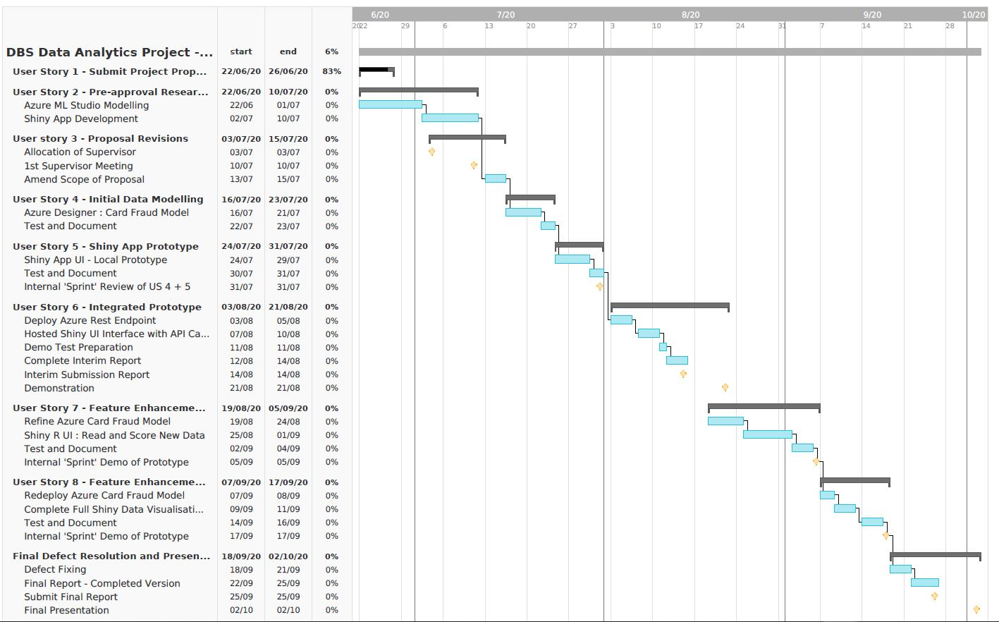

# Future Work

Suggestions on refinements or changes in direction from original project proposal should be made here. These must be justified.

# Appendices

Any code, specifications which should be included in the report should be included in appendices. User manual can also be included here.

# References / Bibliography

1. Microsoft Online Documentation (2020), ‘Tutorial: Predict automobile price with the designer (preview)’. Available at:

<https://docs.microsoft.com/en-gb/azure/machine-learning/tutorial-designer-automobile-price-train-score>

(Accessed 4 June 2020)

1. Dominik Krzeminski (June 2018) ‘Create outstanding R Shiny dashboards with the semantic.dashboard package’. Available at:

<https://appsilon.com/create-outstanding-dashboards-with-the-new-semantic-dashboard-package/>

(Accessed 1 June 2020).

1. Andy Kipp (May 2017), ‘Shinyapps.io – Getting started’. Available at:

<https://shiny.rstudio.com/articles/shinyapps.html>

(Accessed 16 June 2020)

1. Filip Stachura (December 2016) ‘We Have Created a Package to Improve the UI of Shiny Dashboards’. Available at:

<https://appsilon.com/why-have-we-created-package-to-improve-shiny-apps-user-interface/>

(Accessed 23 June 2020)

1. Tim Warner (December 2019). ‘Microsoft Azure AI Engineer: Developing ML Pipelines in Microsoft Azure’. Available at:

<https://app.pluralsight.com/library/courses/microsoft-azure-developing-ml-pipelines/table-of-contents>

(Accessed 10 June 2020)

1. ‘Wikipedia: Agile software development’ (no date). Available at:

<https://en.wikipedia.org/wiki/Agile_software_development>

(Accessed 1 June 2020)

1. ‘Welcome to TeamGantt’ (no date). Available at:

<https://support.teamgantt.com/article/77-welcome-to-teamgantt/>

(Accessed 17 June 2020)